VETERINARSKI ARHIV

Title of a manuscript

**Name Surname1, Name Surname1*, Name Surname1 and Name Surname2**

1Affiliation (Department/Clinic, Insitution, City, Country)

2 Affiliation

**ABSTRACT**

Should not exceed 20 lines (250 words) and should contain full information regarding the results of the study. It should explain the aim of the paper and include the most relevant results and conclusions.

No abbreviations, equations, illustrations, figures, tables or references.

**Key words:**

Use up to 6 key words to identify the object, problem and method of study.

**For example:** cattle; cloning; PCR-RFLP; LHR/HhaI; association study

**Introduction**

# Should be brief and should include recent references concerning the topic, and a meaningful statement of purpose (objective).

# Introductory part should clearly describe the aim of the research.

# A short section explaining the relevance of the research presented in that context should be included.

# Materials and methods

# The experimental part should be written clearly and with sufficient detail about the protocol used to allow the work to be repeated.

# Detailed descriptions are only required for new techniques and procedures, while known methods must be cited in the references. Statistical procedures and software used to analyse the results, including the probability level at which the significance was determined, should be described.

# Do not mention tables and figures that present the results in this section.

# Results

# Use the International System of Units SI symbols for all units.

# The position of all tables and figures should be indicated in the text.

# Discussion

# Emphasize the new and important aspects of the study, and the conclusions that follow from them. Do not repeat in detail data or other material given in the Introduction or the Results section. The Discussion section should provide the authors' interpretation of the significance of the results obtained. Crucial information in the research should be emphasized and interpreted in the context of previously published work.

# Conclusions

# Link the Conclusions with the goals of the study, but avoid unqualified statements and conclusions not adequately supported by the data. Conclusions should concisely and clearly explain the significance and novelty of the results obtained in the presented work. References are not to be cited here.

# Ethics approval/statement

# Finnancial support / statement

# Authorship contribution

# Declaration of competing interest

# Aknowledgments

# If the authors wish to express their thanks for some service, information, financial support, donations or any other assistance, this should be inserted at the very end of the text, preceding the References.

# References

# 1. Periodicals with DOI:

# a. GYURANECZ, M., B. D. RANNALS, C. A. ALLEN, S. JANOSI, P. S. KEIM, J. T. FORSTER (2013): Within-host evolution of Brucella canis during a canine brucellosis outbreak in a kennel. BMC Vet. Res. 9, 76-81.

# doi:10.1186/1746-6148-9-76.

# b.VALDEZATE, S., A. NAVARRO, P. VILLALON, G. CARRASCO, J. A. SAEZ-NIETO (2010): Epidemiological and phylogenetic analysis of Spanish human Brucella melitensis strains by multiple-locus variable-number tandem-repeat typing, hypervariable octameric oligonucleotide fingerprinting, and rpoB typing. J. Clin. Microbiol. 48, 2734-2740.

# doi:10.1128/JCM.00533-10

# 2. Periodicals without DOI:

# SERPE, L., P. GALLO, N. FIDANZA, A. SCARAMUZZO, D. FENIZIA (1999): Single-step method for rapid detection of Brucella spp. in soft cheese by gene-specific polymerase chain reaction. J. Dairy Res. 66, 313-317.

# 3. For Congresses and Symposia:

# FRASER, D. (2010): Animal welfare and the veterinary profession: 50 years of change. Proceedings of the 21st International Pig Veterinary Society Congress, 18-21 July, Vancouver, Canada, pp. 7-10.

# 4. For books:

# RADOSTITS, O. M., C. C. GAY, K. W. HINCHCLIFF, P. D. CONSTABLE (2007): Veterinary Medicine. A textbook of the diseases of cattle, horses, sheep, pigs, and goats. Paratuberculosis (Johne’s disease). 10th ed., Saunders Elsevier, Edinburgh, London, New york, Oxford, Philadelphia, St. Louis, Sydney, Toronto, pp. 1017-1044.

# 5. Chapters in the book:

# COLITZ, C. M. H., V. KUONEN (2007): Ocular infections. In: Equine Infectious Diseases. (Sellon, D. C., M.T. Long, Eds.), Saunders Elsevier, St. Louis, pp. 106-115.

# 6. Theses:

# BRINKHOF, J. (2009): Detection and control of lentiviral infections in sheep and goats. PhD Thesis, Utrecht University, Utrecht, The Netherlands.

**Figures: (**Figure legends should be placed **below** each figure)

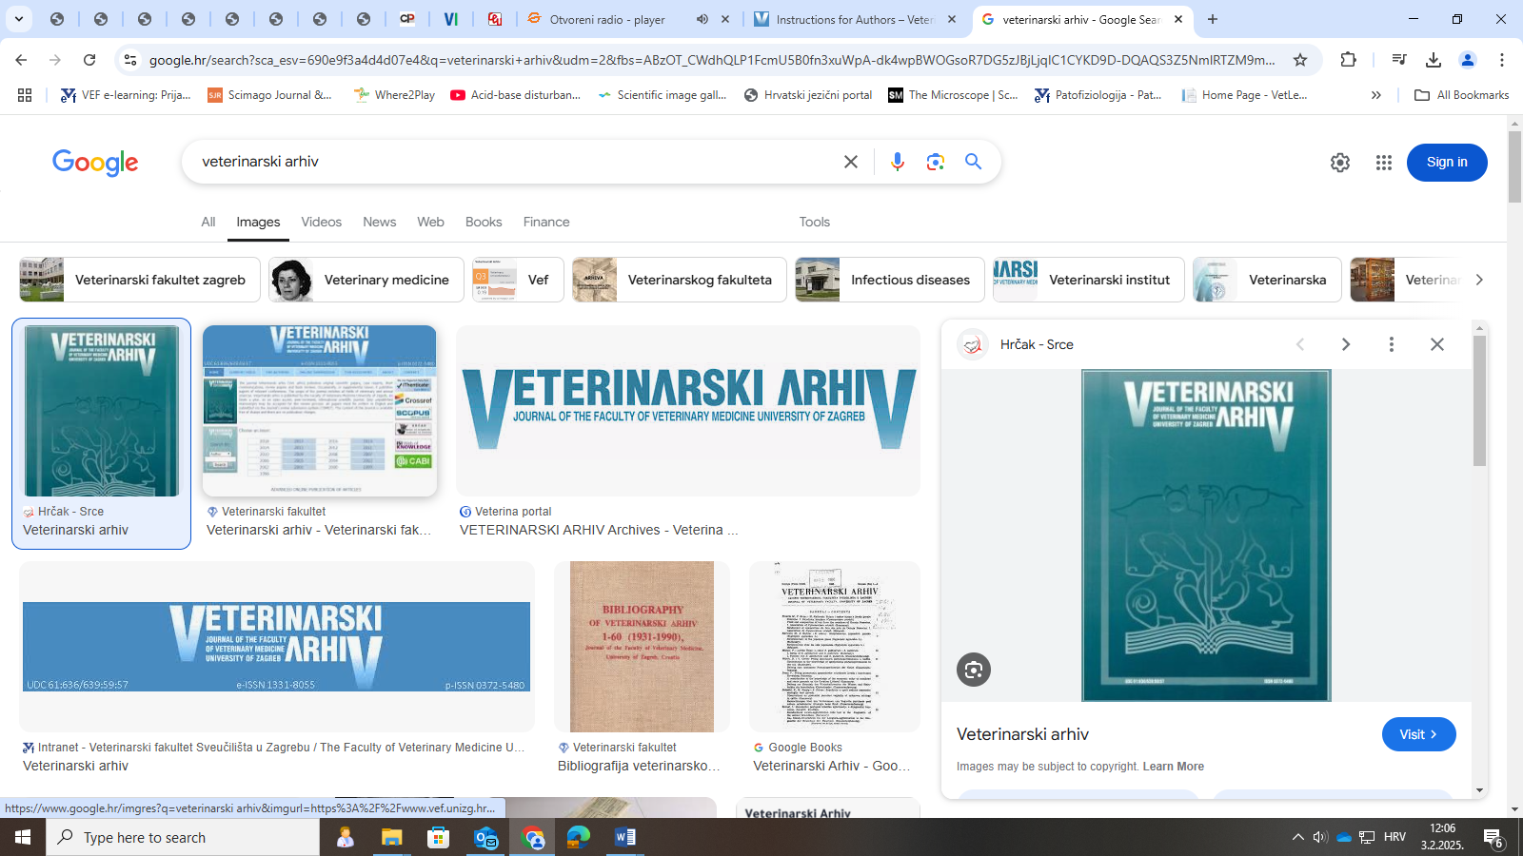

Fig. 1. Figure legends should be placed **below** each figure

**Tables:** Table headings should appear **above** the tables.

Table 1. Table headings should appear **above** the tables.

|  |  |  |  |
| --- | --- | --- | --- |
| **Number of patients** | **Species** | **Age (in years)** | **P value** |
| 1 | Dog | 1 | P>0.05 |
| 2 | Cat | 2 | P<0.05 |
| 3 | Dog | 3 | P<0.05 |
| 4 | Cat | 4 | P>0.05 |
| 5 | Dog | 5 | P<0.05 |